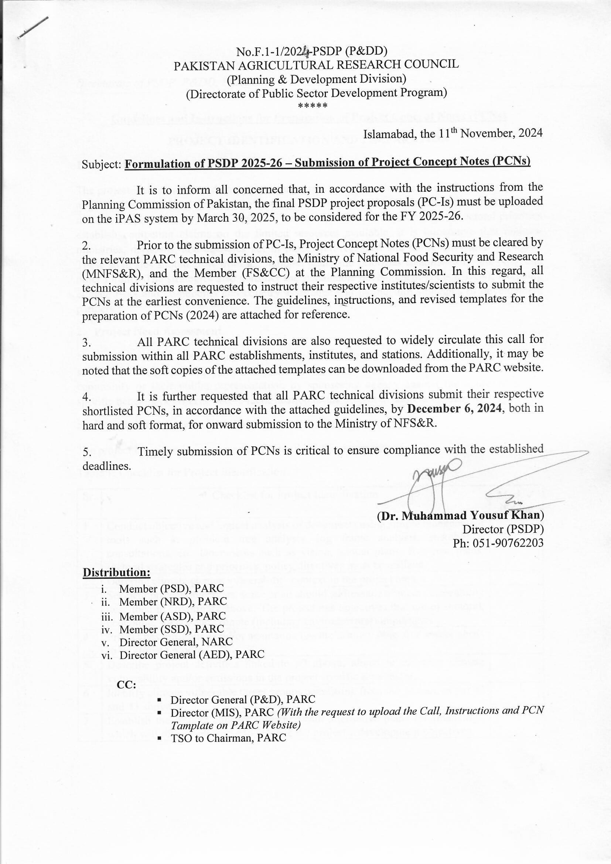

**Guidelines and Instructions for Preparation of Project Concept Notes (PCNs)**

**PROJECT IDENTIFICATION AND PREPARATION**

1. **Introduction:**

The project identification and conceptualization process ensure that the selected projects are fully aligned with the national development goals and public policy objectives. Thus, the project concept must be in sync with the Vision, the Five-Year Plan, and sectoral priorities. As sectoral priorities establish competing claims on the limited resources available, it is imperative that relevant ministries, divisions, and agencies put in place well-reasoned and consensus-based strategies. These strategies should flow from the national plans and priorities established by the NEC and other forums. The strategies also consider the sustainable development goals (SDGs), including climate risks and co-benefits and country assistance and partnership strategies of development partners.

1. **Project Need Assessment**

Need assessment is establishing socio-economic and commercial demand for infrastructure/ service that the proposed project is supposed to address. Assessment of need, identified by the community or their public representative, by sponsoring agency against the approved sector specific benchmark/criteria, before identification of the project to address the same through PCN.

1. **Project Identification Process**

The project identification process constitutes the following steps:

Table 1: Checklist for Project Identification

|  |  |  |
| --- | --- | --- |
| Sr. | Checklist for Project Identification | Mark ✓  if done |
| 1 | Conduct objective and logical analysis of documents using simple management tools such as problem tree analysis, log frame analysis, stakeholder consultations, etc. Documents such as vision, annual plans, five-year plans, sectoral strategies and priorities, policy directives must be utilized. |  |
| 2 | Describe climate change vulnerability context in the project area |  |
| 3 | Set clear project objectives, some or all should address the climate vulnerability described in column #2 above. The project has objectives that are of sectoral, economic, social, and climate (including environmental) importance |  |
| 4 | Project has mitigation and/or adaptation has the primary objective and/or needs to be climate proofed |  |
| 5 | Describe project activities linked to #3 above, aimed at reducing climate vulnerability and/or emissions in the project specific area/sector. |  |
| 6 | Identify climate vulnerable target groups benefitting from the project, as per #2 and #3 above. |  |
| 7 | Establish the project concept (together with alternative plans for financing), which will effectively serve to achieve the project’s development objectives. |  |
| 8 | Assess the priority or urgency of the project in the context of economic and social environment & Climate l development plans and sector investment programs. |  |
| 9 | Examine consistency with the relevant sector policies and master plan and the regional/area development plan |  |
| 10 | Consider the adequacy of the executing agency and the possibility of private sector participation in the project. |  |
| 11 | Estimate approximate project cost (together with the cost of alternatives) based on the conceptual design. |  |
| 12 | Make a preliminary assessment of the feasibility of the project and its development impacts on the country, its specific region or sector including CHIRA |  |
| 13 | Assess project sustainability (economic/financial, environmental, and social). Also evaluate the project’s contribution to the achievement of SDGs, and the impact on climate change. |  |
| 14 | Evaluate the project’s contribution to reducing the climate vulnerability and achievement of national climate and SDGs goals and targets. |  |

1. **Common Mistakes in the Project Identification Process**

During Project Identification/Preparation level, the following common mistakes are made and must be avoided:

Table 2: Common mistakes in the project identification process

|  |  |  |
| --- | --- | --- |
| **Data and assumptions** | **Finances** | **Process** |
| * Inadequacy of data to present factual position * An incorrect assumption of availability of inputs | * Unrealistic cost estimates * Overestimation of benefits * Ambiguity about availability of funding and financing for the project. * Improper financial phasing incommensurate with physical phasing, lack of proper cost-benefit, risk assessment, sensitivity stakeholders consultation, environmental and sustainability analysis | * Lack of proper implementation schedule. * Lack of coordination with relevant agencies * Extensive time is taken by sponsoring/executing agencies with responding to observations of planning commission and modification in the PC-I. |

1. **Project Concept Note (PCN)**

The project identification phase should conclude with the preparation of a PCN, which is a prerequisite for the initiation of project preparation. The PCN is cleared by the concerned Member of Planning Commission. PCN must also include the estimated expenditure and source of funding for project preparation etc. for example climate co-benefits for adaptation or mitigation. The approved PCN should signal the start of project preparation and the authorization to incur Pre-project approval expenditures to that extent. All projects included in the PSDP/ADP should have an approved PCN, with the clearance/approval date of the PCN as the official commencement date of the project. Templet for the PCN is given at ANNEXURE- I.

1. **Appraisal Steps**

Project shall only be considered for approval of CDWP/ECNEC after proper appraisal by concerned Economic & Technical Sections of Planning Commission. An appraisal involves the following steps:

1. Preliminary Examination regarding usage of respective template, proper filling of respective columns, signatures of certificates, attachment of PCN and other relevant documents (design, detailed cost estimates etc.) compliance of procedure & instructions to fill the proformas and uploading on iPas by PIA section.
2. A careful checking of the basic data, assumptions and methodology used in project preparation,
3. An in-depth review of the work plan, cost estimates and proposed financing and O&M cost
4. An assessment of the project’s organizational and management aspects,
5. Validity of the financial, economic, and social benefits to be accrued from the project.
6. Concerned Technical Section will prepare Working Paper on the respective templet.
7. A pre-CDWP meeting will be carried out under the chair of respective Member to consider and settle basic observations and issues before placing it to the CDWP.
8. On the same analogy, appraisal will be carried out by DDWP.

**OVERALL SUBMISSION PROCESS OF PCN & PC-I**

Step-1: "Scientist prepares PCN"

Step-2: "Submit PCN to the relevant PARC Division"

Step-3: "Appraisal and scrutiny by the concerned PARC Division"

Step-4: "Each division submits 3 shortlisted PCNs to the Directorate of PSDP & P&DD"

Step-5: "Review, vetting, and compilation of PCNs for approval"

Step-6: "Submit approved PCNs to MNFS&R for review"

Step-7: "Present PCNs to the Secretary of MNFS&R"

Step-8: "Improve shortlisted PCNs as per MNFS&R guidelines"

Step-9: "Submit PCNs to the Technical Section (F&A), M/o PD&SI"

Step-10: "Present PCNs to the Member PD&SI for clearance"

Step-11: "Chairman PARC approves the PCNs"

◊◊◊◊◊◊◊◊◊◊◊◊◊◊◊

Step-12: "Prepare PC-I based on PARC, MNFS&R, and M/o PD&SI guidelines"

Step-13: "Submit PC-I to the Directorate of PSDP & P&DD"

Step-14: "Conduct financial and technical vetting of PC-I"

Step-15: "Improve PC-I by the relevant Technical Division/Scientist"

Step-16: "Chairman PARC approves PC-I submission to MNFS&R"

Step-17: "Submit and present PC-Is to MNFS&R for review"

Step-18: "Further improvement by the concerned Technical Division at PARC"

Step-19: "Chairman PARC approves PC-I submission to MNFS&R"

Step-20: "Secretary MNFS&R approves PC-I for submission to PD&SI"

Step-21: "Upload the approved PC-I to iPAS (Deadline: 30.03.2025)"

******

*While shortlisting project proposals, PARC's technical divisions should ensure they are innovative, provide solutions to existing problems, have a socio-economic impact on national agriculture and the economy, and are economically viable, technically sound, financially profitable, managerially efficient, institutionally feasible, and socially acceptable.*

**Annexture-1**

Revised 2024

**Project Concept Note (PCN) Template**

|  |  |  |
| --- | --- | --- |
| 1 | Basic information | • Project Name |
| • Executing Agency and Implementing Agency |
| • Sector /Subsector(s) and/or Theme & Location |
| • Project Implementation Period (Start Date and End Date) |
| 2 | Background | 1. **Give Problem Statement:** State the problem that will be addressed as well as the underlying causes 2. **State Project Rationale:** Give justification for the project underpinning importance of the project by aligning it with national and sectoral programmes and policies 3. **Provide facts, data and references to support the argument** 4. **What solutions are you proposing to address the problem stated above?** 5. **Mention existing work done, if any (if it is a revised project/amendment)** 6. **Mention project beneficiaries** 7. **Provide project brief Scope of Work** |
| 3 | Project Objective | **Instructions:**  1. **Define the project overall objective clearly indicating what you expect from the project.**  **2. Mention how many objectives does your project have**  **3. The objectives should fall under one or more of the following categories (also specify):**  **4. Every project should have the following 4 Objectives, each with upto 2 sub-objectives:**  **I.** **Sectoral** Importance:  i) **Alignment with the sectoral policy:** every sector has a policy and give specific reference to the section of the policy to indicate that if accepted, the project will help in implementation of an existing policy.  ii) **Strategic Importance:** explain why this specific project or intervention has strategic value with the policy.  iii) **Inter-sectoral linkages:** highlight any intersectoral linkages If it is helping meet the objectives of other sectoral priorities/policies.  **II.** **Economic** Importance  I. How the project will have immediate/direct economic benefits in terms of   * 1. Enhance exports,   2. Reduce imports,   3. Productivity,   4. Enhance national capacity pay back debt.   II. Job creation   1. During implementation, 2. After completion of the project.   III. Strengthen infrastructural national capacity with national infrastructural needs.  **III.** **Social** Importance  I. How will the project promote inclusion:   1. Promote gender equity, 2. Promote social, economic, environment and climate rights, 3. Promote participation of minorities/underprivileged   II. How will the project strengthen participation of concerned communities.   1. Skill development of local population, 2. Create livelihoods, 3. Community consultation/participation in development, delivery and impact assessment of the project.   III. How will the project help will local level socioeconomic conditions by:   1. Reducing local level poverty, 2. Local level government and nongovernment institutions.   **IV.** **Climate & Environmental** importance   1. How will it help with environmental protection (such as deforestation, change in land zoning, and encroachment of agricultural land, river banks, water bodies or watersheds)? 2. How it will help reduce climate damages (such floods, heatwaves, droughts, floods, landslides, tropical storms, etc) and losses (ecosystem depletion, water availability air quality etc.) or slow the degradation of ecosystems/slow onset of climate change? 3. How will it help with adaptation, mitigation and co-benefits? |
| 4 | Description of Activities, Outputs and Outcome | 1. **Each activity and output and Outcome should be aligned with the objectives given above.**   **I.** **Describe the logical framework for each component.**   1. what are the actions or activities to be undertaken to achieve the state objectives desired outputs? and 2. link them with the expected outcome.   **II.** **Design monitoring framework.**   1. Assign indicators at both output and outcome level in order to track the progress both during the project implementation and beyond its completion**1**[1]. 2. Use tabular format for quantifiable and verifiable framework, based on monitoring framework, giving benchmarks. Attach annexure if more space is needed. Refer Table 1 (Annex-II) for template. 3. Provide only those indicators that are measurable or binary in nature. 4. **Depending** on the nature of the project, if the objective is linked to climate change mitigation or adaptation then provide at least one indicator and highlight it. However, if the project is not directly linked to climate change try to develop casual links to climate mitigation or adaptation indicators, based on initial screening exercise given in CHIRA. 5. Provide an Indicative Logical Framework as an Annex to the concept note (see Table 1 (Annex 2) at the end of template). |
| 5 | Project cost | 1. Include a summary budget table (format given in the Table 2 (Annex 3) at the end of template). 2. Mention if there is any foreign exchange, private sector investment, co-financing involved and mention the co-financier(s), Size and Terms). 3. Mention if the financing is through ADP, PSDP, allocation for future etc. 4. Is there any percentage of cost allocated for Adaptation and Mitigation? If yes, please specify the amount |
| 6 | Are plans for monitoring, reporting and evaluation in place? | |  |  | | --- | --- | | Yes | No |   If yes, please rank   |  |  |  | | --- | --- | --- | | 1-High Risk | 2-Medium Risk | 3-Low Risk | |
| 7 | Is there any component for Gender Equality and Mainstreaming? | |  |  | | --- | --- | | Yes | No |   If yes, please rank   |  |  |  | | --- | --- | --- | | 1-High Risk | 2-Medium Risk | 3-Low Risk | |
| 8. | Are there any Environmental, Social or Climate risks involved? | |  |  | | --- | --- | | Yes | No |   If yes, please rank   |  |  |  | | --- | --- | --- | | 1-High Risk | 2-Medium Risk | 3-Low Risk | |
| 9. | Risk Assessment: Are there any strategic risk, stakeholder risk, financial risk involved that suggest the project to be conducted as PPP? | **Strategic risk:**   |  |  | | --- | --- | | Yes | No |   If yes, please rank   |  |  |  | | --- | --- | --- | | 1-High Risk | 2-Medium Risk | 3-Low Risk |   **Stakeholder risk:**     |  |  | | --- | --- | | Yes | No |   If yes, please rank   |  |  |  | | --- | --- | --- | | 1-High Risk | 2-Medium Risk | 3-Low Risk |   **Financial risk:**   |  |  | | --- | --- | | Yes | No |   If yes, please rank   |  |  |  | | --- | --- | --- | | 1-High Risk | 2-Medium Risk | 3-Low Risk | |
| 10 | The Climate and Hazard Initial Risk Assessment (CHIRA) indicate the project to be undertaken | If yes, please rank   |  |  |  | | --- | --- | --- | | 1-High Risk | 2-Medium Risk | 3-Low Risk | |

|  |  |  |  |  |
| --- | --- | --- | --- | --- |
| 11 | If medium and high risk, does the project has incorporated a mitigation and/or adaptation objective. State here. | |  |  | | --- | --- | | Yes | No |   Please refer the objective #4, at para # 3 |
| 12 | Next Steps | 1. Are there any key issues, not covered above?  2. How do you plan to overcome these when developing the PC-I? |

***Note:*** *Please attach annexures i, ii, iii & iv with the PCN. All PCNs must be signed and stamped by the concerned Scientist and due details i.e. Designation, Institute Name and Contact Nos. must be provided.*

**Annexure-i**

**Project Brief Description**

Guidelines for project Brief Description:

A project brief is a short summary of a project's key elements, such as its goals, scope, and deliverables. It's a high-level overview that's intended to be clear and concise, and is typically one paragraph to one page long.

A brief description of a project typically includes the following key elements:

1. **Project Title**: A clear and concise name that reflects the core objective or focus of the project.
2. **Objective**: A statement outlining the primary goal or purpose of the project, specifying what it aims to achieve.
3. **Scope**: A summary of the main activities, deliverables, and boundaries of the project, highlighting key tasks and milestones.
4. **Duration**: The estimated timeframe for completing the project, including start and end dates or key phases.
5. **Stakeholders**: Key individuals or groups involved in or impacted by the project, such as team members, sponsors, or clients.
6. **Expected Outcomes**: The anticipated results or benefits, describing how the project will add value or solve a specific problem.

**Annexure - ii**

**Indicative Logical Framework**

**Table 1: Template for Indicative Logical Framework**

|  |  |  |  |  |  |  |  |  |  |  |
| --- | --- | --- | --- | --- | --- | --- | --- | --- | --- | --- |
| Project Objectives | Activities / Actions | Outputs | Output Indicator | Timeline | Desired Outcomes | Outcome Indicator | Timeline | Impacts | Impact Indicator | Timeline |
| Sectoral Objective | | | | | | | | | | |
| Sub-objective- 1 | Activity 1  Activity 2:  Activity 3: | Output 1:  Output 2:  Outputs 3: | Output 1 Indicator  Output 2 Indicator  Output 3 Indicator | By 20?? Quarter wise Start date add By 20?? | Outcome 1  Outcome 2 | Outcome 1 Indicator  Outcome 2 Indicator | By 20??  By 20?? | Impact | Impact 1 Indicator | By 20?? |
| Sub objective- 2 | Activity 1  Activity 2:  Activity 3: |  |  |  |  |  |  |  |  |  |
| **Economic Objective** | | | | | | | | | | |
| Sub-objective- 1 |  |  |  |  |  |  |  |  |  |  |
| Sub-objective- 2 |  |  |  |  |  |  |  |  |  |  |
| Social Objective | | | | | | | | | | |
| Sub-objective- 1 |  |  |  |  |  |  |  |  |  |  |
| Sub-objective- 2 |  |  |  |  |  |  |  |  |  |  |
| **Climate Objective** | | | | | | | | | | |
| Sub-objective- 1 |  |  |  |  |  |  |  |  |  |  |
| Sub-objective- 2 |  |  |  |  |  |  |  |  |  |  |

**Annexure –iii**

**Project Budget and M&E Framework**

**Table 2: Template for Project Budget**

|  |  |
| --- | --- |
| **Components** | **Cost in Rupees** |
| Sectoral Objective |  |
| Economic Objective |  |
| Social Objective |  |
| Climate & Environmental Objective |  |
| Project Management and Administrative Costs |  |
| Adaptation, Mitigation and/or Co-benefits (CHIRA results) |  |

**Annexure - iv**

**Table 3: Monitoring & Evaluation (M&E) Framework Template**

|  |  |  |  |  |  |  |  |  |  |  |
| --- | --- | --- | --- | --- | --- | --- | --- | --- | --- | --- |
|  | INDICATOR | DEFINITION How is it calculated? | BASELINE What is the current value? | TARGET What is the target value? | DATA SOURCE How will  it be measured? | FREQUENCY How often will  it be measured? | RESPONSIBLE Who will  measure it? | REPORTING Where will it be reported? | COST What will be the cost? | TIMELINE When will the expected target be achieved? |
| Objective 1 (Sectoral Impact) |  |  |  |  |  |  |  |  |  |  |
| Outcome 1.1 |  |  |  |  |  |  |  |  |  |  |
| Output 1.1.1 |  |  |  |  |  |  |  |  |  |  |
| Output 1.1.2 |  |  |  |  |  |  |  |  |  |  |
| Outcome 1.2 |  |  |  |  |  |  |  |  |  |  |
| Output 1.2.1.2 |  |  |  |  |  |  |  |  |  |  |
| Output 1.2 |  |  |  |  |  |  |  |  |  |  |
| Objective 2 (Economic Impact) |  |  |  |  |  |  |  |  |  |  |
| Outcome 2.1 |  |  |  |  |  |  |  |  |  |  |
| Output 2.1.1 |  |  |  |  |  |  |  |  |  |  |
| Output 2.1.2 |  |  |  |  |  |  |  |  |  |  |
| Outcome 2.2 |  |  |  |  |  |  |  |  |  |  |
| Output 2.2.1 |  |  |  |  |  |  |  |  |  |  |
| Output 2.2.2 |  |  |  |  |  |  |  |  |  |  |
| Objective 3 (Social Impact) |  |  |  |  |  |  |  |  |  |  |
| Outcome 3.1 |  |  |  |  |  |  |  |  |  |  |
| Output 3.1.1 |  |  |  |  |  |  |  |  |  |  |
| Output 3.1.2 |  |  |  |  |  |  |  |  |  |  |
| Outcome 3.2 |  |  |  |  |  |  |  |  |  |  |
| Output 3.2.1 |  |  |  |  |  |  |  |  |  |  |
| Output 3.2.2 |  |  |  |  |  |  |  |  |  |  |
| Objective 4 (Climate & Environmental Impact) |  |  |  |  |  |  |  |  |  |  |
| Outcome 4.1 |  |  |  |  |  |  |  |  |  |  |
| Output 4.1.1 |  |  |  |  |  |  |  |  |  |  |
| Output 4.1.2 |  |  |  |  |  |  |  |  |  |  |
| Outcome 4.2 |  |  |  |  |  |  |  |  |  |  |
| Output 4.2.1 |  |  |  |  |  |  |  |  |  |  |
| Output 4.2.2 |  |  |  |  |  |  |  |  |  |  |

* Details on activities/ inputs to be provided in a separate document

* Add additional rows depending on the project objectives/ outputs/ outcomes

*******

1. *Refer to Handbook on Climate Risk Screening for Policy Planning.*